

**North South University**

**Department of Electrical and Computer Engineering**

**CSE215 Project**

**Summer 2023**

**Group number:10**

Team members:

* Sarker Sadman Saalim- 2232843642
* Sadaen Parves Shoumik- 2232042042

Section: 14.

Project name: Public Transport Management System.

**Abstraction:**

In today’s fast-paced world, efficient transportation systems are crucial to ensuring smooth and convenient travel. The Transportation Management System (TMS) project is designed to facilitate easy and efficient bus ticket booking for individuals. This system enables travelers to book their bus tickets conveniently through any smart device, enhancing the overall travel experience. The TMS primarily focuses on bus transportation management, streamlining the process of booking tickets and providing valuable features for both passengers and bus operators.

**Introduction:**

The Transportation Management System (TMS) is like a smart tool for booking bus tickets. It's designed to make booking a bus ticket easy and convenient, especially in the digital age where everything is online. This project helps travelers book tickets without any hassle and also helps bus companies run their services more smoothly. It's all about making bus travel simple and efficient for everyone involved.

The project was made using JAVA. It uses various .java files for its classes, interfaces, abstract classes. It was made keeping in mind all concepts of Object Oriented Programming (OOP) in JAVA.

**Methodology**

**Uses/Functions:**

The Transportation Management System will offer the following features:

* User Registration and Authentication: Users can create accounts and authenticate themselves securely.
* Bus Search and Booking: Passengers can search for available bus routes, select their preferred bus, and book tickets.
* Real-time Bus Schedules: Passengers can access up-to-date information on bus schedules and availability.
* Online Payment: Integration with payment gateways to facilitate secure online payments.
* Ticket Confirmation: Passengers will receive email or SMS notifications with ticket details after successful booking.

**Project Benefits:**

* User Convenience: The system aims to offer a seamless and convenient experience for travelers by allowing them to book and manage their bus tickets from any smart device with internet connectivity.
* Real-time Information: Passengers can access real-time information on bus schedules, availability, and pricing, ensuring they make informed decisions.
* Payment Integration: The TMS will integrate various payment gateways to make the booking and payment process secure and hassle-free.

**Project Block Diagram**

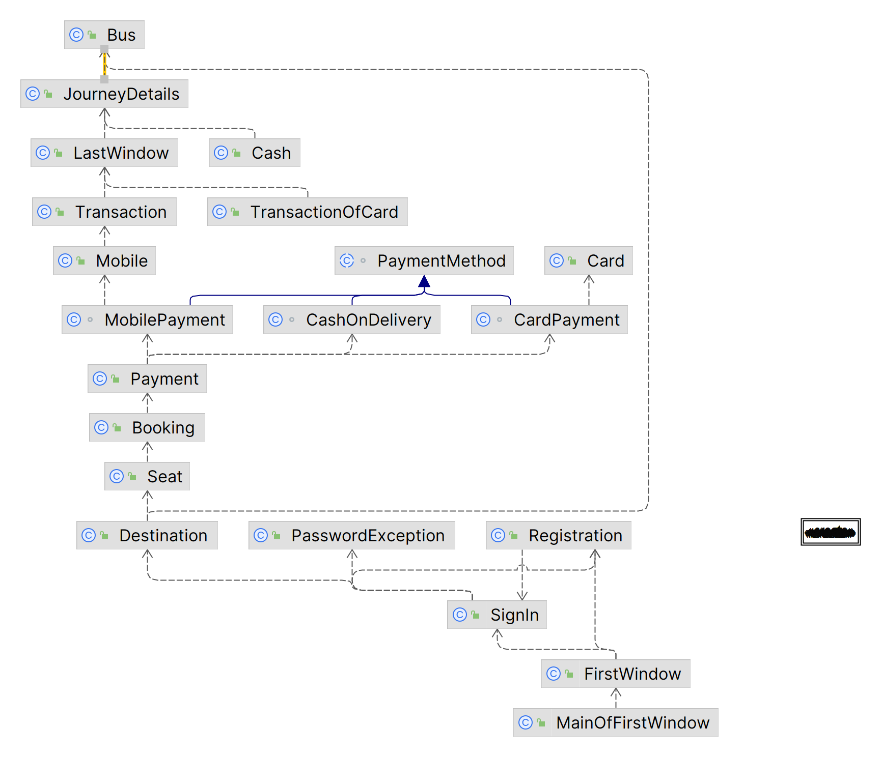

**UML Diagram**

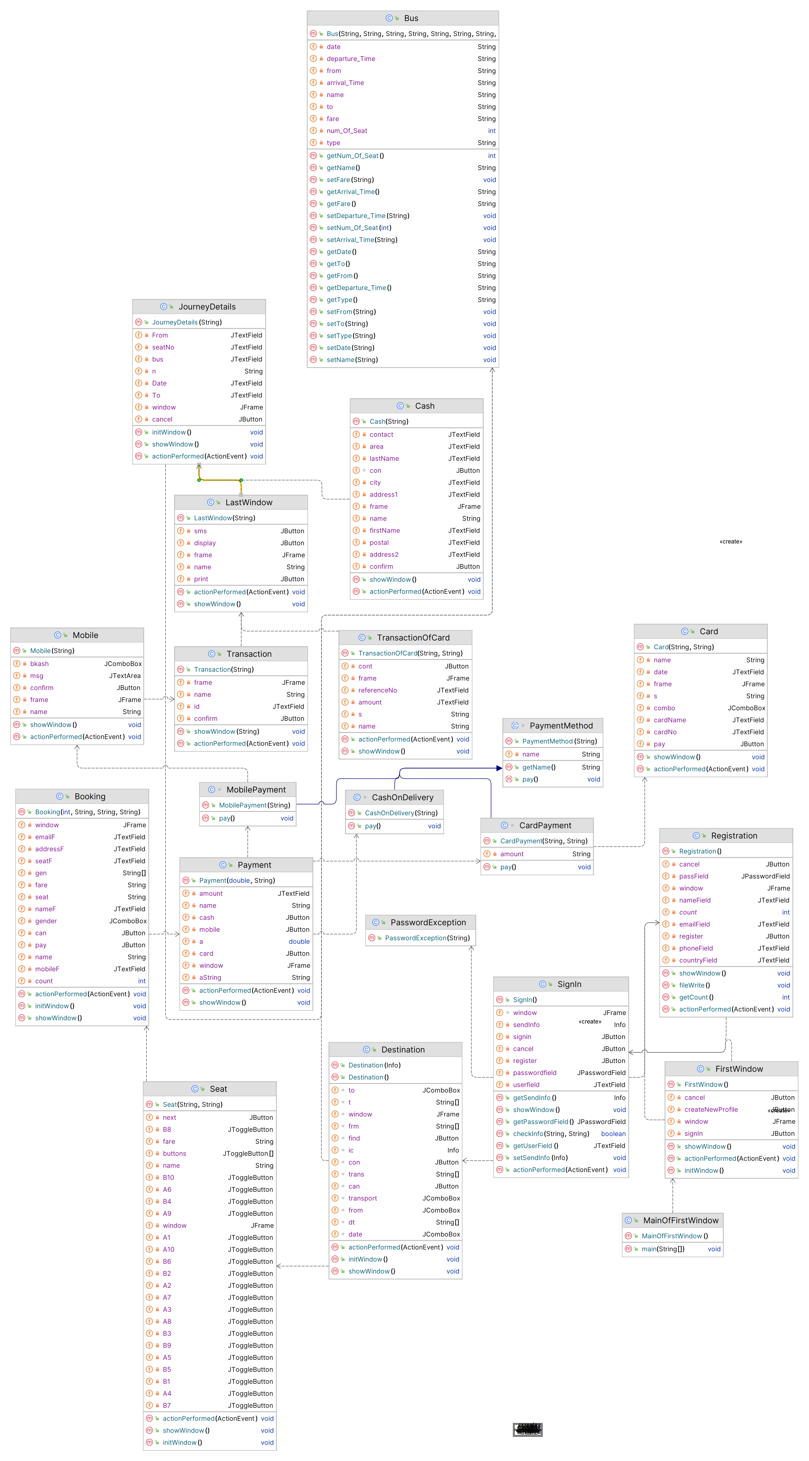





**Conclusion:**

In conclusion, the Transportation Management System (TMS) project represents a significant step towards simplifying and modernizing the process of booking bus tickets. With the widespread use of smartphones and the internet, the TMS offers a convenient way for travelers to plan their journeys. It not only benefits passengers by making ticket booking easier but also improves the efficiency and management of bus transportation services for operators.

The TMS project is poised to contribute to the growth of the bus transportation industry by reducing complexities and enhancing user experiences. As the digital landscape continues to evolve, TMS serves as a bridge between travelers and bus operators, fostering a more connected and accessible transport system. The convenience, real-time information, and secure payment options it provides are essential in today's fast-paced world. This project demonstrates the potential for technology to simplify and improve everyday experiences, making bus travel more accessible and enjoyable for all.